Which entity of the composite pattern cannot implement "add()" operation?

1. **Client**
2. Composite
3. Component
4. Leaf

What 2 methods we can usually find in an implementation of Visitor Design Pattern?

1. "accept(Visitor v)" and "visit(Element e)"
2. **"accept(Visitor v)" and "visit(ConcreteElement e)"**
3. "accept(ConcreteVisitor v)" and "visit(Element e)"
4. "accept(ConcreteVisitor v)" and "visit(ConcreteElement e)"

What pattern is displayed on following diagram?

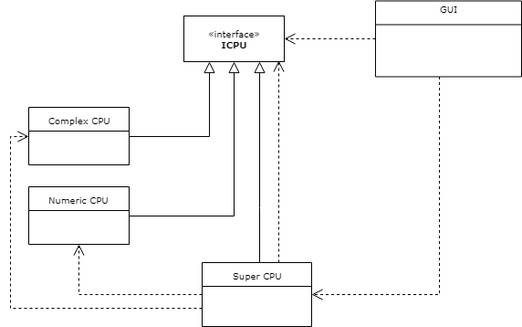

1. Abstract Factory
2. Visitor
3. Strategy
4. **Composite**

Abstract Factory is a

1. Structural Pattern
2. Behavioral Pattern
3. J2EE Pattern
4. **Creational Pattern**

Strategy pattern is used to:

1. **switch algorithm at run time**
2. switch algorithm at compile time
3. to replace part of execution code at runtime
4. focus on architecture of the system

Parent of concrete strategies can be

1. Interface only
2. Abstract method only
3. Interface or other class
4. **Interface or abstract class**